39.21: 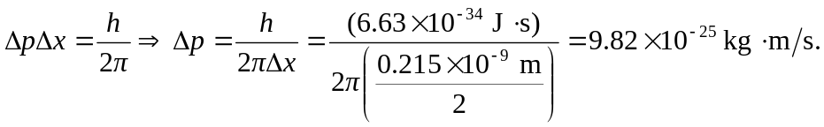 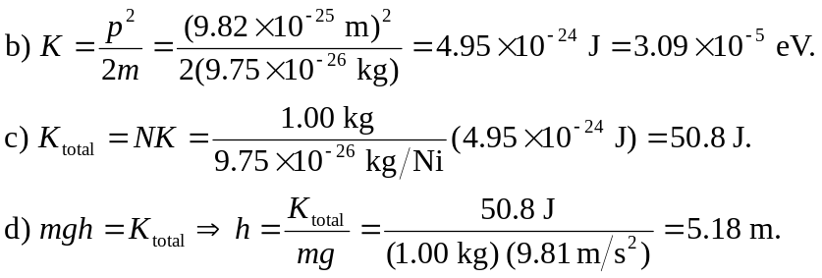
e) One is claiming to know both an exact momentum for each atom (giving rise to an exact kinetic energy of the system) and an exact position of each atom (giving rise to an exact potential energy of the system), in violation of Heisenberg’s uncertainty principle.

